In__________, an end product speeds up its production
A. positive feedback
B. negative feedback
C. Both A and B
D. None of these
ANSWER: A
In___________, end products results in the reversal of the direction of change and tends to maintain homeostasis
A. positive feedback
B. negative feedback
C. Both A and B
D. None of these
ANSWER: B
An example of _________ is childbirth
A. positive feedback
B. negative feedback
C. Both A and B
D. None of these
ANSWER: A
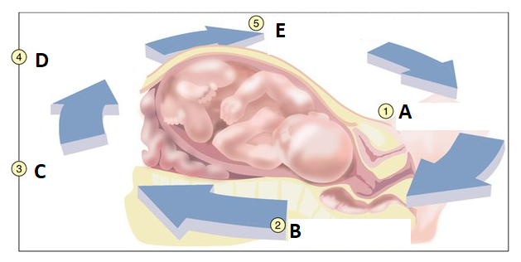
Childbirth is an example of
A. positive feedback
B. negative feedback
C. Both A and B
D. None of these
ANSWER: A

What does A represent in the given diagram?
A. Brain stimulates pituitary gland to secrete oxytocin
B. Nerve impulses from cervix transmitted to brain
C. Head of fetus pushes against cervix
D. Oxytocin carried in bloodstream to uterus
ANSWER: C

What does B represent in the given diagram?
A. Brain stimulates pituitary gland to secrete oxytocin
B. Nerve impulses from cervix transmitted to brain
C. Head of fetus pushes against cervix
D. Oxytocin carried in bloodstream to uterus
ANSWER: B

What does C represent in the given diagram?
A. oxytocin stimulates uterine contractions and pushes fetus towards cervix
B. Nerve impulses from cervix transmitted to brain
C. Brain stimulates pituitary gland to secrete oxytocin
D. Oxytocin carried in bloodstream to uterus
ANSWER: C

What does D represent in the given diagram?
A. oxytocin stimulates uterine contractions and pushes fetus towards cervix
B. Nerve impulses from cervix transmitted to brain
C. Brain stimulates pituitary gland to secrete oxytocin
D. Oxytocin carried in bloodstream to uterus
ANSWER: D

What does E represent in the given diagram?
A. oxytocin stimulates uterine contractions and pushes fetus towards cervix
B. Nerve impulses from cervix transmitted to brain
C. Brain stimulates pituitary gland to secrete oxytocin
D. Oxytocin carried in bloodstream to uterus
ANSWER: A
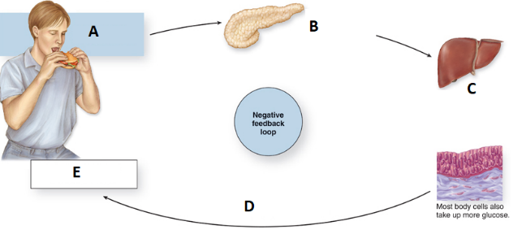
What does B represent in the given diagram?
A. Stimulus; rising blood glucose level
B. High blood glucose level is detected by insulin-secreting cells of the pancreas
C. Pancreas secretes the hormone insulin causing liver cells to take up glucose and store it as glycogen
D. As body cells take up blood glucose, glucose levels in the blood decline, and insulin release stops (negative feedback)
ANSWER: B

What does A represent in the given diagram?
A. Stimulus; rising blood glucose level
B. High blood glucose level is detected by insulin-secreting cells of the pancreas
C. Pancreas secretes the hormone insulin causing liver cells to take up glucose and store it as glycogen
D. As body cells take up blood glucose, glucose levels in the blood decline, and insulin release stops (negative feedback)
ANSWER: A

What does D represent in the given diagram?
A. Stimulus; rising blood glucose level
B. High blood glucose level is detected by insulin-secreting cells of the pancreas
C. Pancreas secretes the hormone insulin causing liver cells to take up glucose and store it as glycogen
D. As body cells take up blood glucose, glucose levels in the blood decline, and insulin release stops (negative feedback)
ANSWER: D

What does C represent in the given diagram?
A. Stimulus; rising blood glucose level
B. High blood glucose level is detected by insulin-secreting cells of the pancreas
C. Pancreas secretes the hormone insulin causing liver cells to take up glucose and store it as glycogen
D. As body cells take up blood glucose, glucose levels in the blood decline, and insulin release stops (negative feedback)
ANSWER: C

What does E represent in the given diagram?
A. Stimulus; rising blood glucose level
B. Return to homeostatic blood glucose level
C. Pancreas secretes the hormone insulin causing liver cells to take up glucose and store it as glycogen
D. As body cells take up blood glucose, glucose levels in the blood decline, and insulin release stops (negative feedback)
ANSWER: B
Glucagon and insulin are:
A. Iodine hormone
B. Secreted by same cells and perform similar function
C. Secreted by different cells and perform antagonistic functions
D. Secreted by same cells and perform antagonistic functions
ANSWER: C

